25-02-2010
George K. Aidoo
SM/SMS/09/0019
Physics Practical

Experiment 5

Measurement of Low Resistance

AIM:

This experiment aims to determine and plot the current/volt characteristics of metal (copper and aluminum) and to calculate their resistances.

APPARATUS:

Heat conductivity rod, Cu and Al (1 each), universal measuring amplifier (1), digital multimeter (2), power supply 0-12 V DC/6 V, 12 V AC (1), connecting cord, l = 100mm, yellow (2), connecting cord, l = 250mm, red and blue (1 each), connecting cord, l = 500mm, red and blue (2 and 1 respectively), connecting cord, l = 750mm, yellow and blue (2 and 1 respectively), and connecting cord, l = 2000mm, yellow (1).

DIAGRAM:

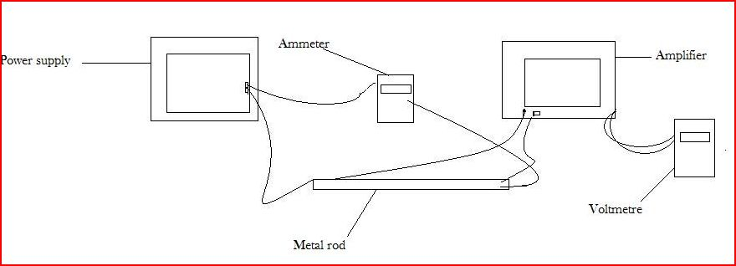

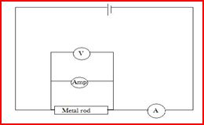

THEORY:

The principle of this experiment is that the resistances of various DC conductors are determined by recording current/voltage characteristics, and then the resistivities of the metal rods are calculated. The resistivity þ of the metal is determined from the resistance R of the rod and its dimensions. The rod has a diameter of 2.5cm (cross-sectional area, A = 4.9 x 10⁻⁴ m²) and is 31.5cm long (length l) between the two voltmeter connections.
From Ohm's law, the resistance of the rod is given as:
R= þ x 1/A.

PROCEDURE:

The amplifier was set to low drift; R = 10⁴Ώ, and the amplification at 10³, the counter constant at 0 sec. Using an ammeter, the metal rod was connected to the mains, and the voltage source was set to 12V. The current was varied at constant intervals of 0.2A. The voltage drop was the measured and recorded at two stocks on the side of the rod, using the amplifier for each current selected. The procedure was repeated using the aluminum rod.

TABLE OF RESULTS (observations):

Table of results for metal rod:

Voltage / mV | Current(I) / A
0.204 | 0.20
0.207 | 0.40
0.212 | 0.60
0.216 | 0.80
0.220 | 1.00

Table of results for copper rod

Voltage / mV | Current(I)
0.205 | 0.20
0.207 | 0.40
0.209 | 0.60
0.212 | 0.80
0.215 | 1.00

Graph of Voltage against Current for both rods:

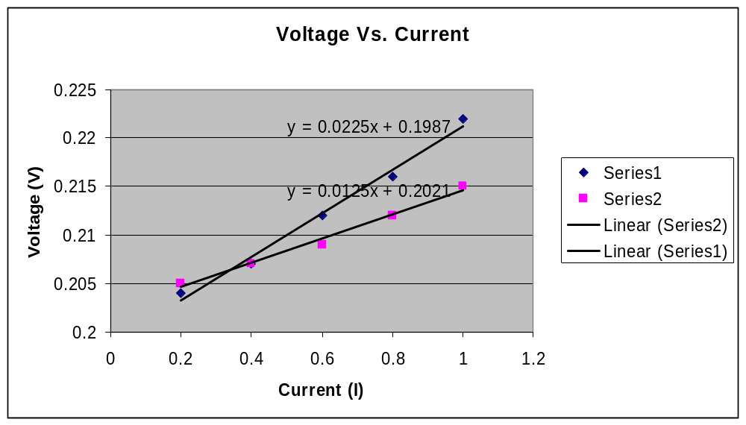

Calculation of the Resistivity and Resistance of each rod:

From the equation in the theory, and the slope of the graph above, the resistivity of each of the metal rods can be determined by:
R = (þ)(l) / A
RA = (þ)(l)
RA / l = (þ)

For the metal rod:
R, determined from the slope from the graph above is: 0.0225 Ώ
The area of the metal rod was: 4.9 x 10⁻⁴ m²
The length of the rod was: 31.5cm
The resistivity of the metal rod is therefore determined:
RA / l = (þ)
(0.0225 Ώ)(4.9 x 10⁻⁴ m²) / 31.5cm = (þ)
(þ) = 3.5x10⁻⁷

For the aluminum rod:
R, determined from the slope from the graph above is: 0.0125 Ώ
The area of the metal rod was: 4.9 x 10⁻⁴ m²
The length of the rod was: 31.5cm
The resistivity of the metal rod is therefore determined:
RA / l = (þ)
(0.0125 Ώ)(4.9 x 10⁻⁴ m²) / 31.5cm = (þ)
(þ) = 1.95x10⁻⁷

DISCUSSION:

The resistivity difference between the two rods; 3.5x10⁻⁷ for the metal rod and 1.95x10⁻⁷ for the aluminum rod, is quiet obvious from the calculations above. As expected, the magnitude of voltage that passed through the metal rod was greater than that of the aluminum rod. The slope of each line in the graph represents the resistance of the corresponding metal rod. It was seen from these values that the metal rod has a greater resistance than the aluminum rod.

SOURCES OF ERROR:

- There may have been errors in this experiment if there was an undetected malfunction in the equipment used.

PRECAUTIONS:

- The rods used in this experiment were carefully designed to avoid electrical shocks during the experiment.

CONCLUSION:

The aim of the experiment to determine the resistivity of two different materials; a metal rod and an aluminum rod, using the slope of a graph of the voltage against the current passing through each rod, was achieved and the experiment was successful.

REFERENCES:

SERWAY, Raymond A., College Physics/Raymond A. Serway, Jerry S. Faughn, - 6th edition, Pacific Groove, CA 93950. USA. Pg. 412-413

